Login

Link: http://www.liza-line.com/wp-admin/

The login information is:
username: Lizaline
Password: tijdelijkwachtwoord

Dashboard

When you login to WordPress, you’ll see the following screen. This is the Back End from the website where you can add and change the website content:

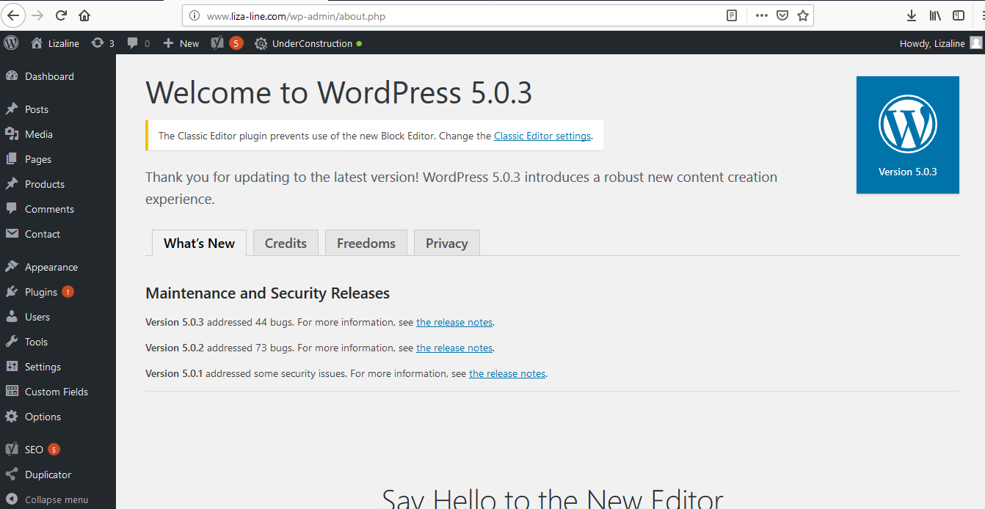

To see the Front End (website), go up to the left and click on the homebutton:

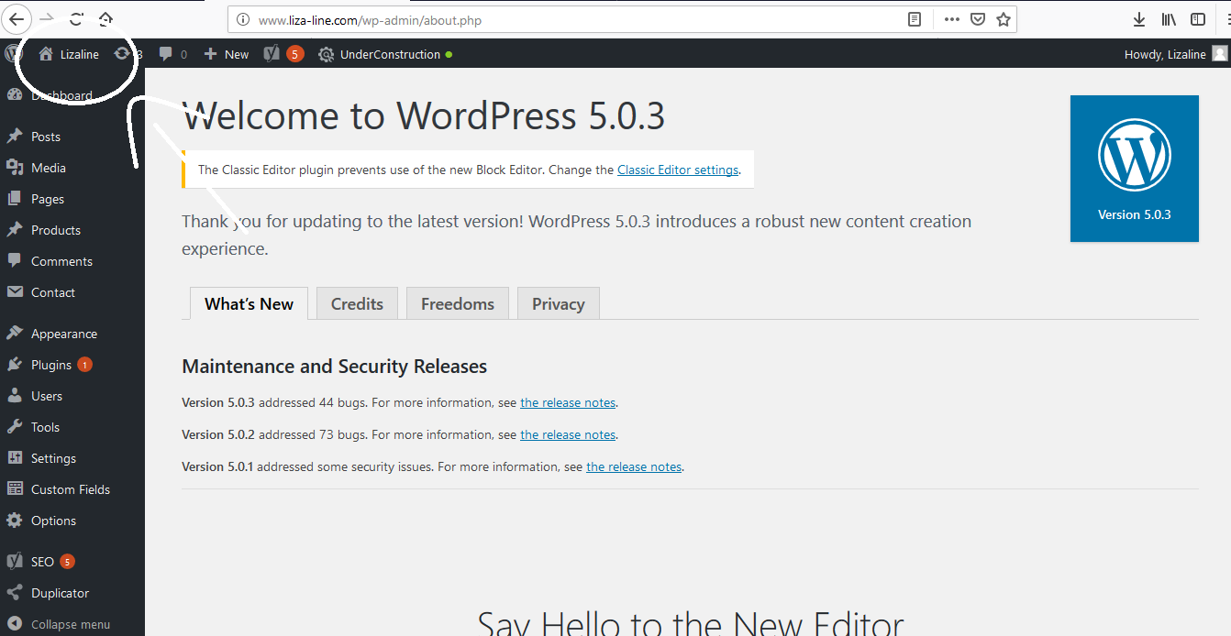
Posts

Here you can add the blogs or other articles. Follow the next steps:

1. Click on Posts - Add new
2. Add the title under ‘Add New Post’
3. Add the text from the article in the big text field.

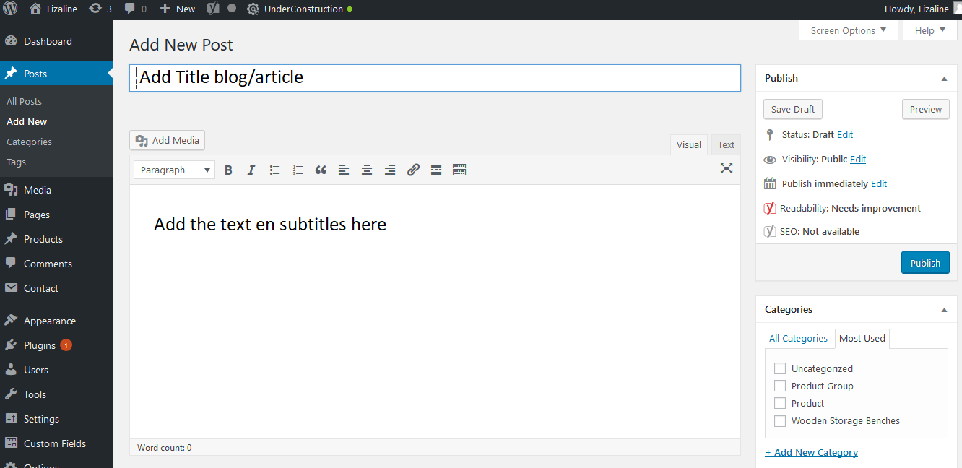
4. Add an image under Featured Image. After you’ve added a featured image, click on the button ‘crop featured image’. To set the right dimensions for showing the picture on the journal page, choose ‘Journal Thumb’.

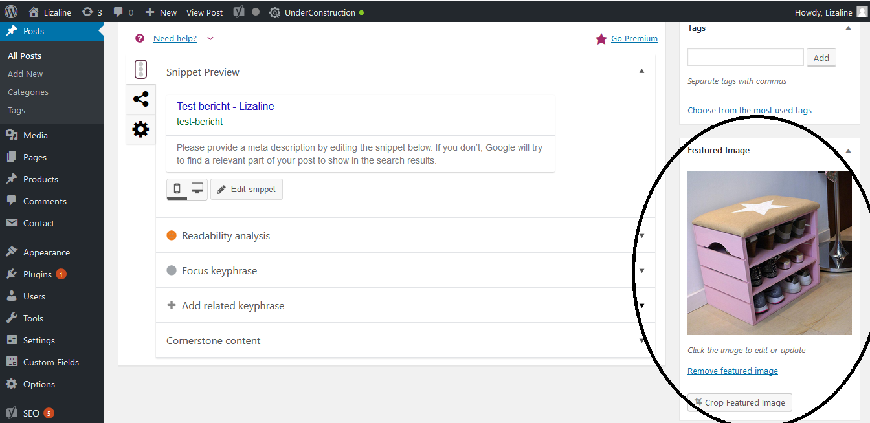
5. For the search function on the website (NOT Google), you can add tags. These are keywords that are related to the blog. When users perform a search in the search section on the website, and the keyword matches with the title, content or tag, the blog is shown in the search results. When Shoe Rack is an important keyword, but it’s already in the title or the blog text, it’s not needed to add it as a tag. The ‘Search’ scans the title and content automatically.

I would recommend to use categories only for the product and category pages, and not for blogs.

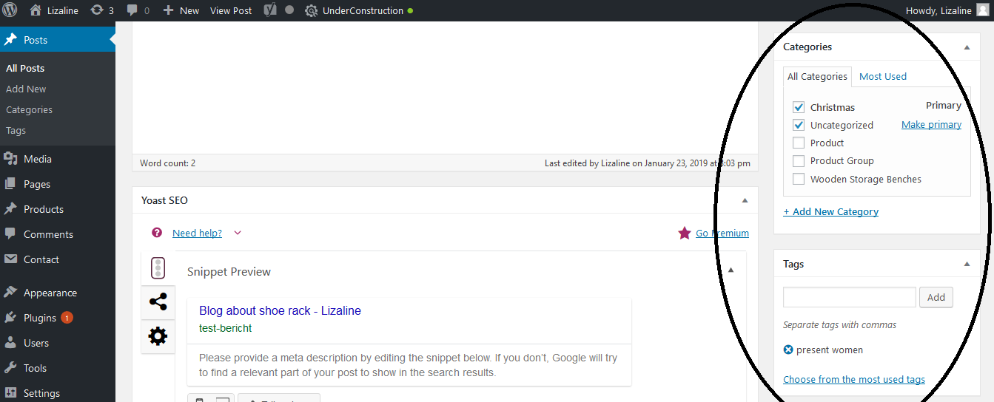
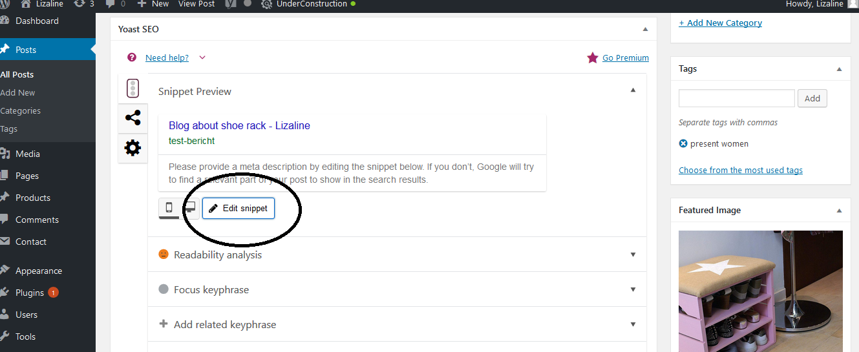
7. When the content is ready to publish, click on the blue button ‘publish’. When you want to publish it later, click on ‘Save draft’.

8. After you save the draft, you can change the permalink. Automatically, It will copy the title. Sometimes it’s better for SEO or usability, to change the permalink.

9. After making changes, always click the button ‘Update’.

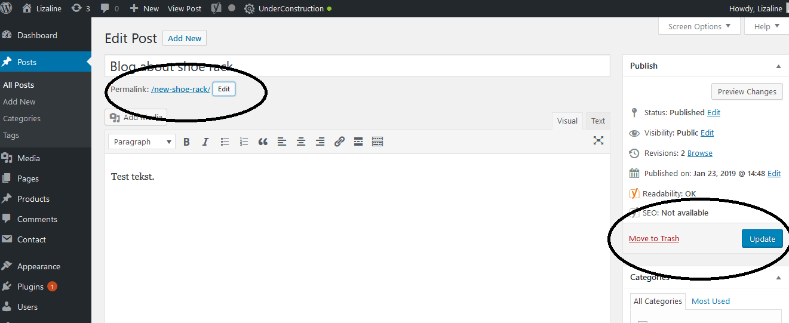

Media

Here you can add images. Follow the next steps:

1. Before adding an image, make sure you’ll do the next things:
- Make the picture less heavier before you add the image via ‘Photoshop’ or another program.
- Save the file under a filename that’s related to your keyword / title product.

2. Go to media - select files. Add the image you want to add to the media library.

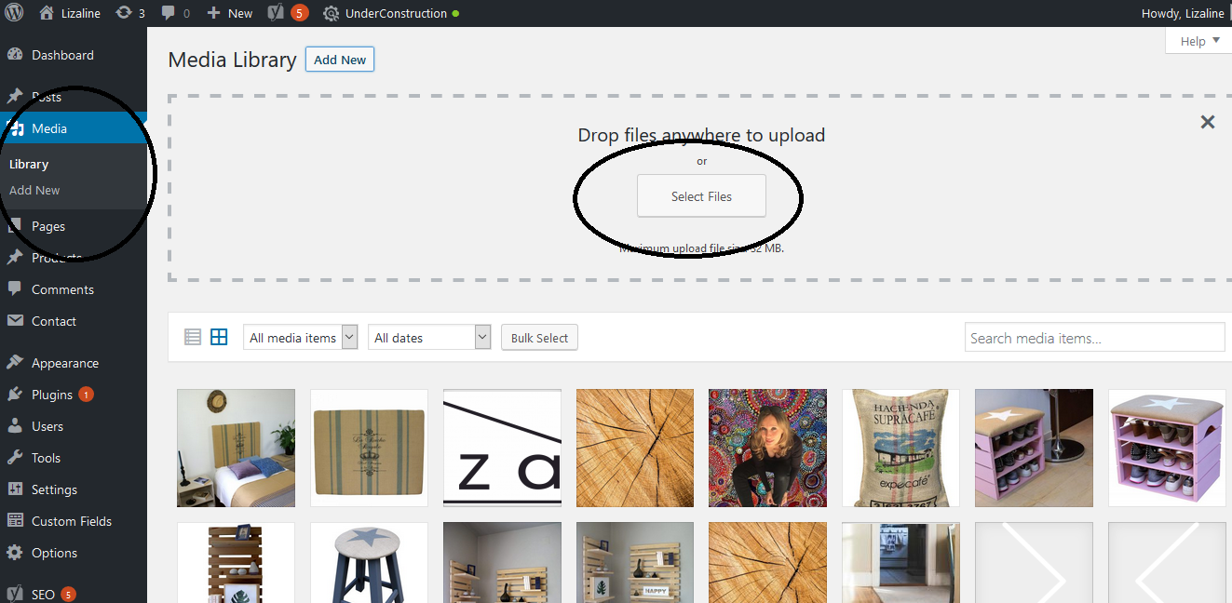

3. Click on the image you’ve added. Add the title, Alt-Tekst and Description. This should be the same as the keyword / product title. This information is good for the usability, accessibility and SEO. Via Edit page you can change the dimensions or crop the picture if necessary.

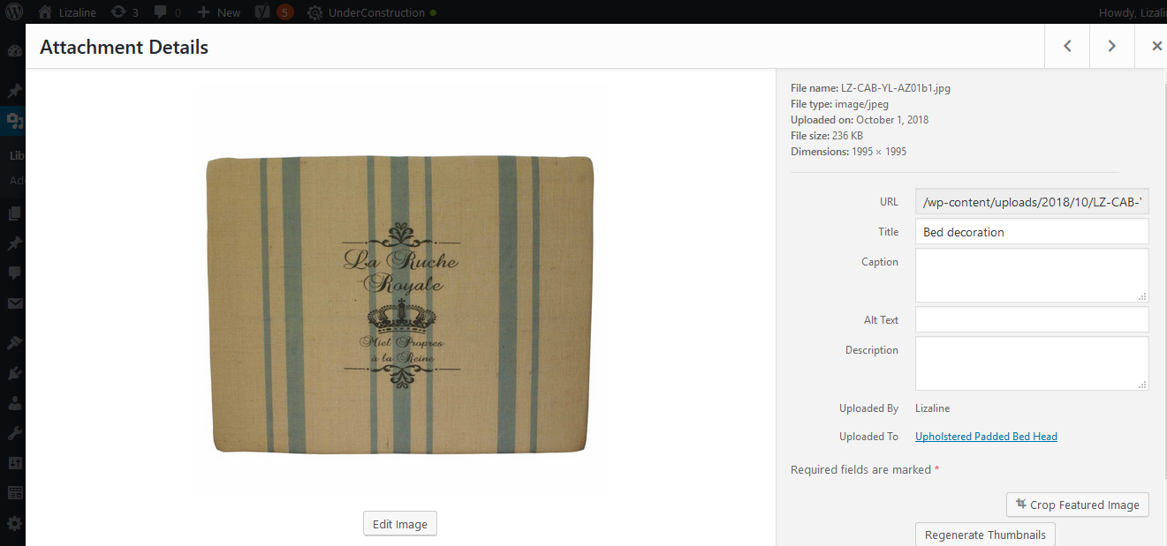

Pages

Here you can make changes to the main pages on the website: Home, About and Contact.

FYI: The Journal shows the latest blogs that are added to posts. You can’t make changes here. The Collection is not a page, only a menu-item.

Home

Here you can change the content on the homepage, under the banner. You can change the banner in the dashboard under ‘Options’.

Guide to change to homepage:

1. You can change the products on the homepage by choosing another picture, add the right product page, and change the description and price.

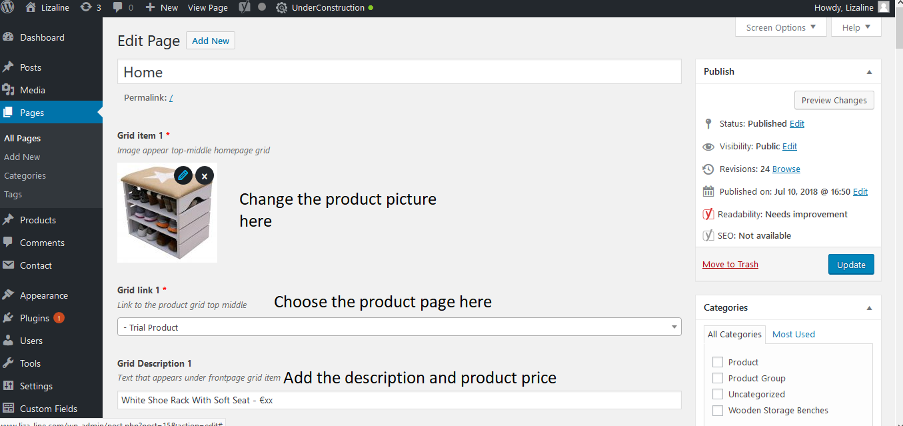
2. Optionally, you can add a corner marker to a product for showing ‘new’ or a ‘discount’. If you don’t want to add the corner market, uncheck the box ‘Selet to show a marker’.

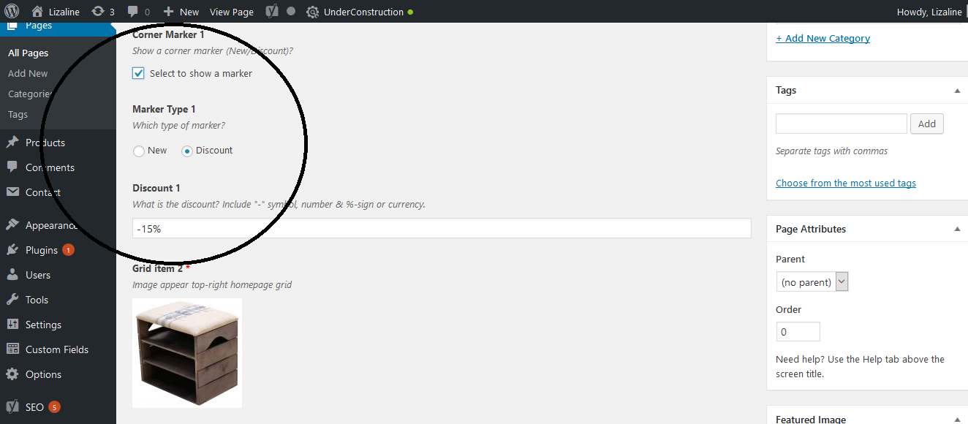
3. You can change the other content blogs under the products. You can change the pictures, text and links.

About and Contact

When you click on the pageAbout or Contact, you can change the content easily in the content fields.

Products

Under products, you can add and change the category pages and product pages.

Add category page

1. Click in the menu in the dashboad on products – add new
2. Choose the right template: Products Listing

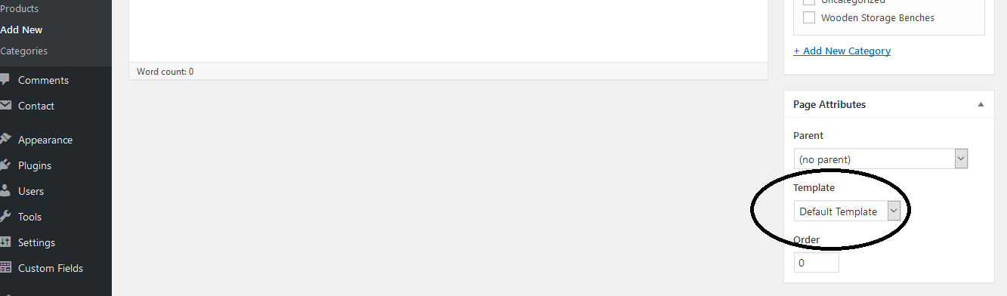
3. Enter the name of the category in the box ‘Enter title here’
4. Check the box ‘Product Group’ under categories (on the right sidebar). This is better for organising the Back End.

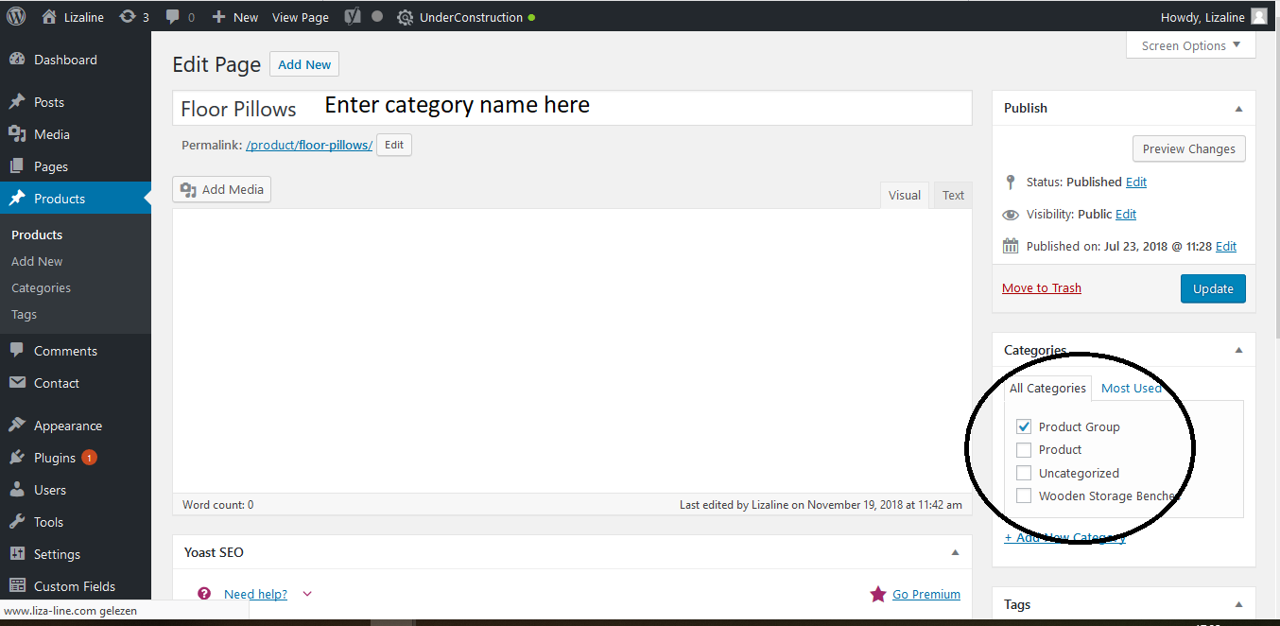
5. You don’t need to do anything else with the category page. Products will be added automatically.
6. To add the category page to the menu, go in this manual to: Appearance – Menus

Add product page

1. Click in the menu in the dashboad on products – add new
2. First, choose the right template: Individual Product
3. Select the parent page: this is the category page where the product will be shown automatically.
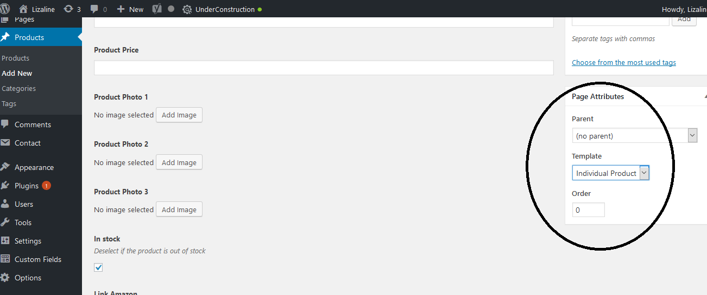
3. Enter the name of the product in the box ‘Enter title here’
4. Check the box ‘Product’ under categories (on the right sidebar)

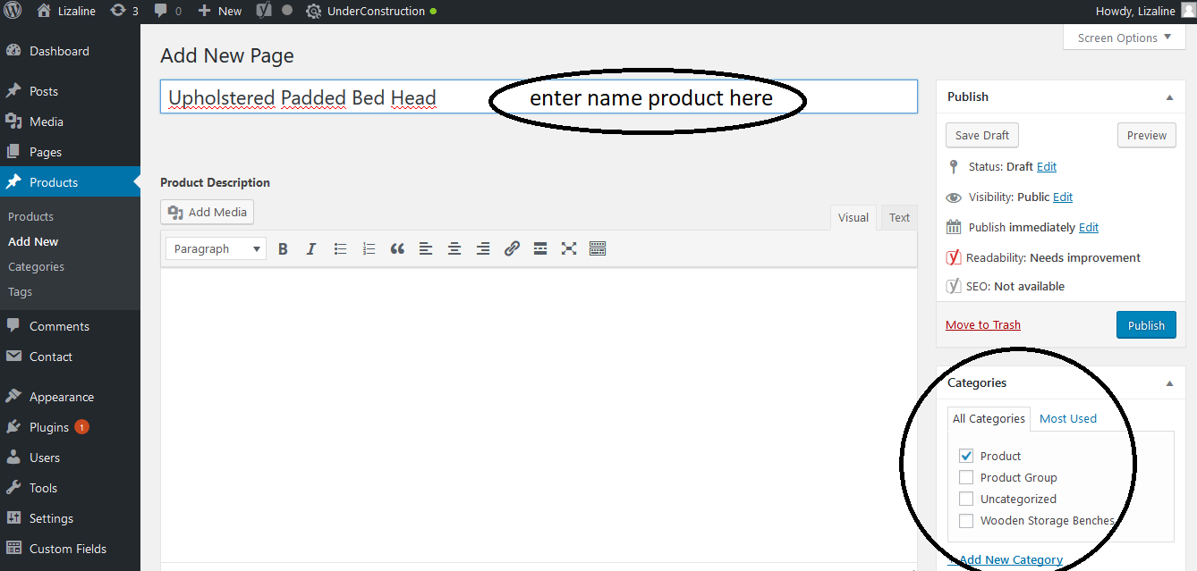
5. Add the product information via the next steps:

a. Product description
This is the information about the product that is shown in the box right.

b. Short description

c. Product Price
Add the price of the product with the valuta sign

d. Images
Add 1 to 3 product images. When you’ve selected an image, always fill in the information on the right (see below) for SEO reasons:Title, Alt Text & Description (no caption)
Add at least the keyword from the page, this should be the same as the name in the product title.

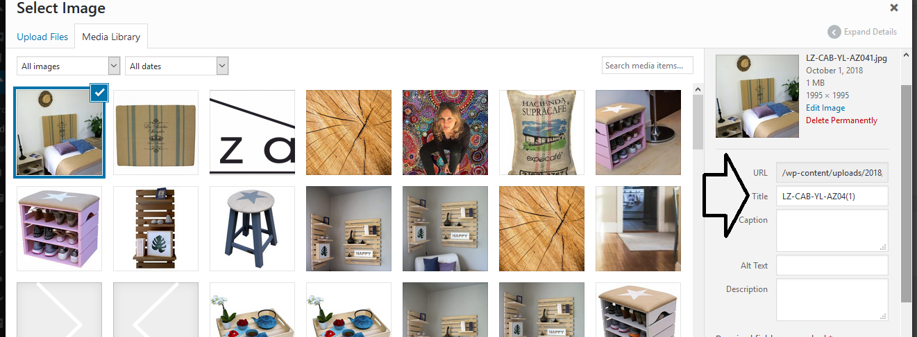
e. In stock:
If a product is out of stock, deselect the box

f. Link Amazon:
This is the link to the product page on Amazon where visitors can buy your product.

g. Similar products, follow the next steps:

1. Add the title you like to show instead of similar products, for example ‘Related Products’ our ‘Products you may also like’
2. Select 1 to 3 similar products. You can choose from another existing product page

h. Optional category pictures

If you want to show different pictures on the category page than that are shown on the product page, you can add them here.

6. After you’ve finished the product page, click on the blue button ‘publish’. Now, it’s visible on the category page.

7. To change the order of the products on the category page, you can fill in a number under ‘Order’ on the product page. The lower the number, the earlier the product is shown on the page.

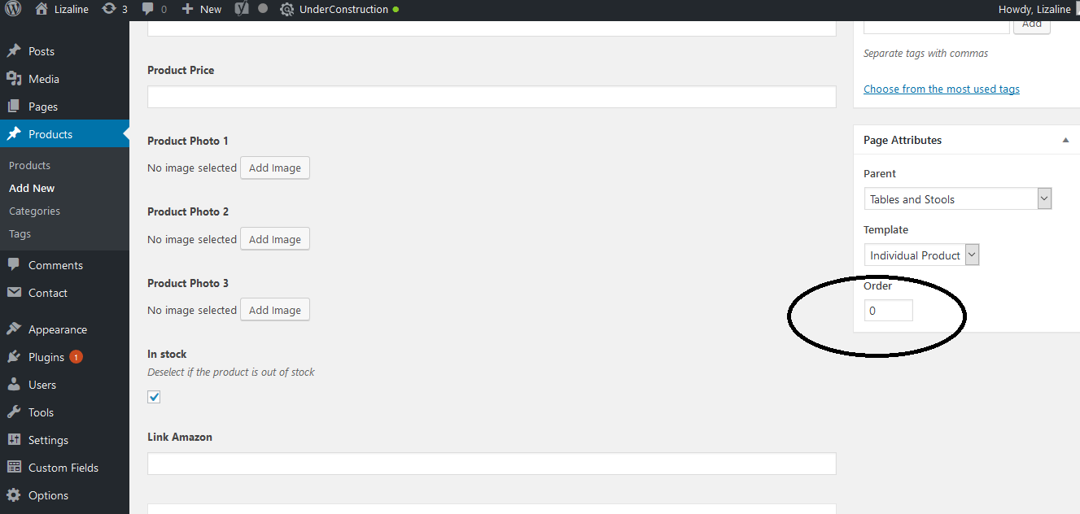

Comments and Contact

You don’t need these menu’s.

Appearance

Under Appearance, you don’t use themes, customize and editor. Only Menus:

Appearance – Menus

Here you can change the menu from the website. This is only interesting if you want to add, delete or change the categories.

Guide to change menu:

1. Go to appearance – menus
2. Select categories

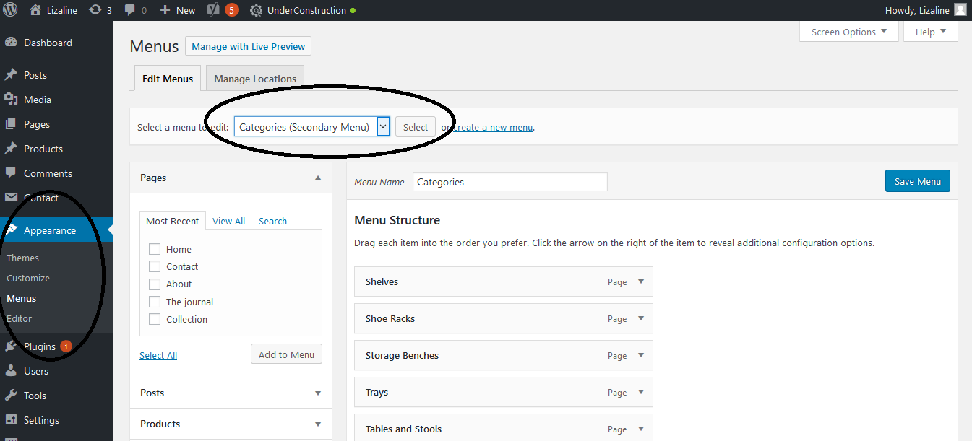

3. Go to categories – view all.
4. To add a new menu-item, select the menu-item and click on ‘add to menu’.
5. To deleta a menu-item, click on the arrow on the menu-item and remove.

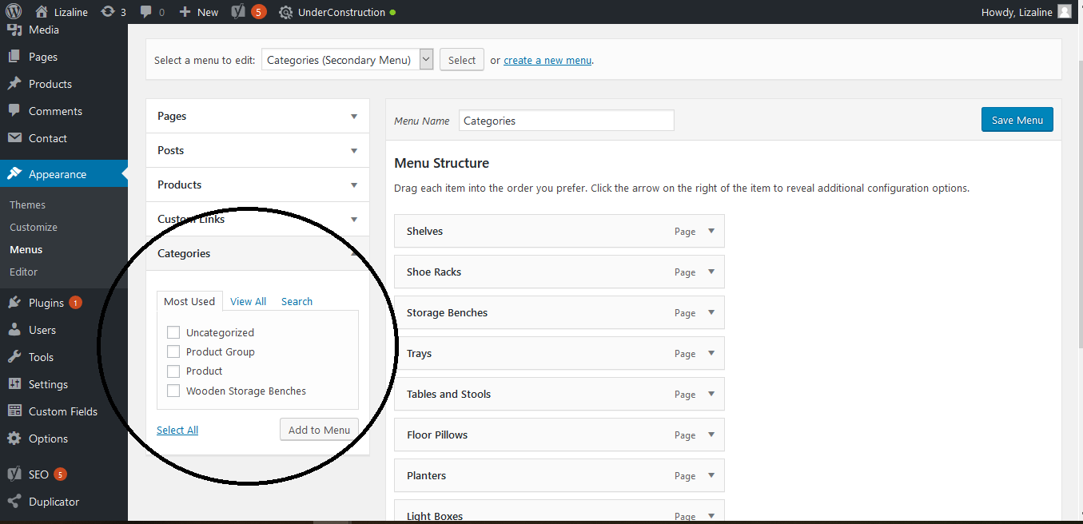

Plugins

The plugins need updates regularly. I would recommend to organise this with the website builder, in case something goes wrong. This could be including the monthly maintanance.

Users, tools, settings, and custom fields

These are items for the website builder.

Options

Here you can change the banner for the homepage. You can change the banners, descriptions and links.

SEO

Two things are important:

1. When the website is ready, we should connect it to Google via Google Search Console. Google can index your website only when that’s done.

2. Add the SEO information for every blog, page, product page etc. You do this through going to every page, underneath ‘Yoast SEO’.

Click on ‘Edit snippet’. Add the SEO Title and Meta Description. This is the informatie that Google shows in the search results.

Read more about this here: https://yoast.com/wordpress/plugins/seo/titles-and-meta-descriptions/

After, go to Focus Keyphrase. Add the keyword (or longtail keyword) for this page. Whit this tool, you can see if your page is optimized for this keyword. It gives you optimize tips for SEO and readability as well.

Read more about keywords here: https://yoast.com/focus-keyword/

Duplicator

This is for making backups from the website. I would recommend to organise this with the website builder regularly, in case something goes wrong. This could be including the monthly maintanance.

